AI ASSISTANT LAB ASSIGNMENT 5.4
NAME: Navya Revuri
2303A52483
Task Description #1:
• Prompt GitHub Copilot to generate a Python script that collects
user data (e.g., name, age, email). Then, ask Copilot to add
comments on how to anonymize or protect this data.
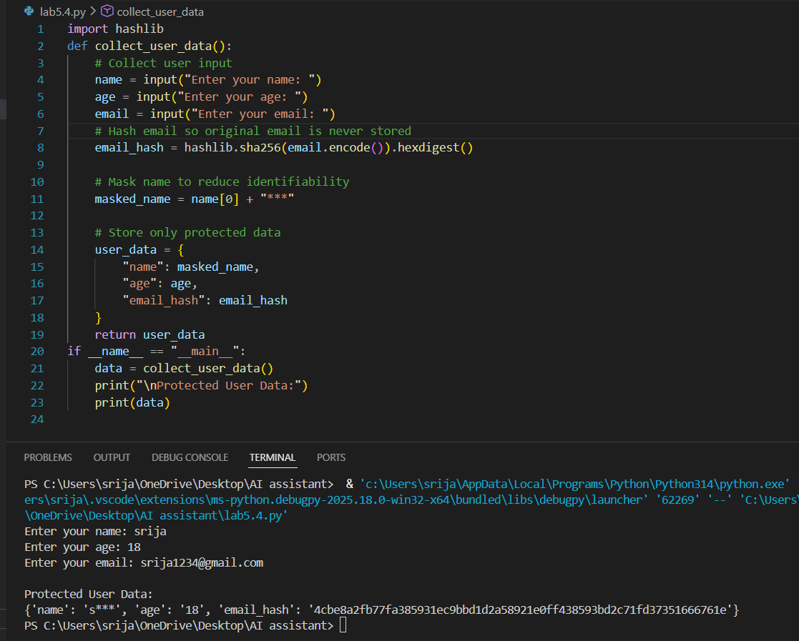

Task Description #2:
Prompt : Sentiment Analysis + Bias Handling
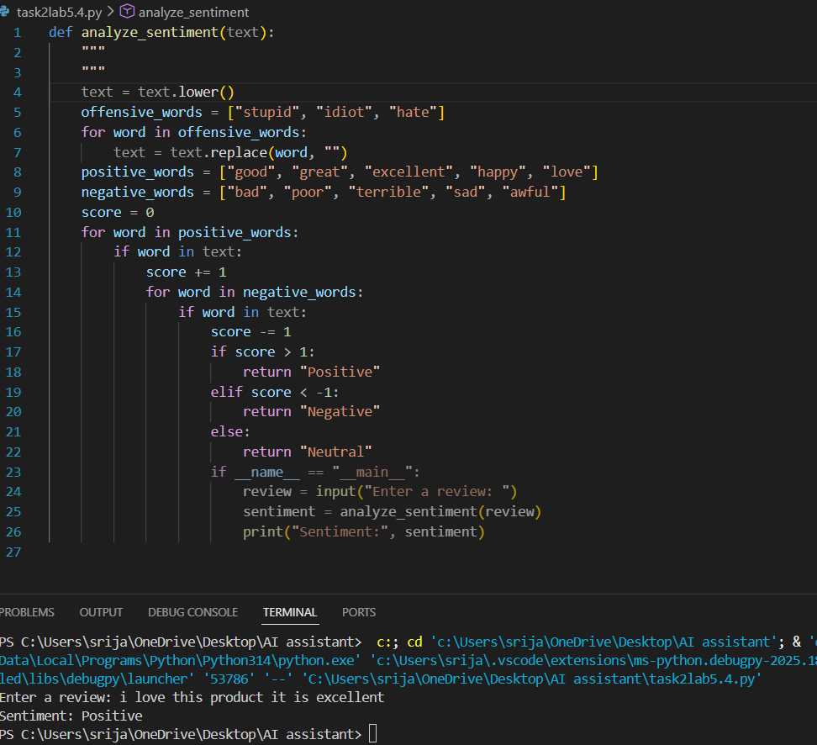

Task 3:
Prompt : Product Recommendation System
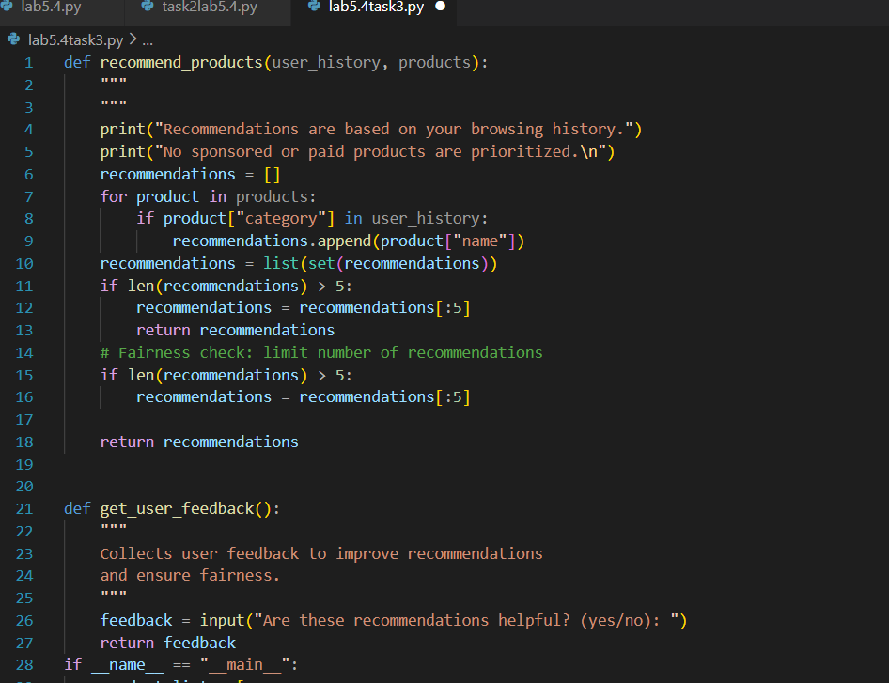

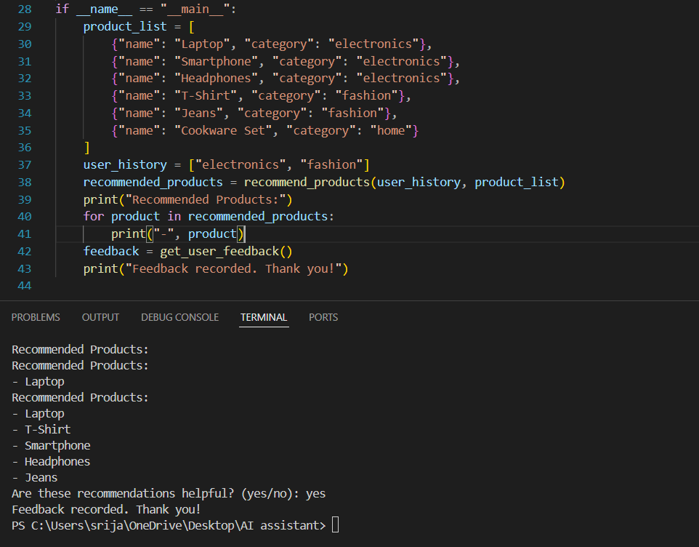
Task4:
Prompt : generate logging functionality
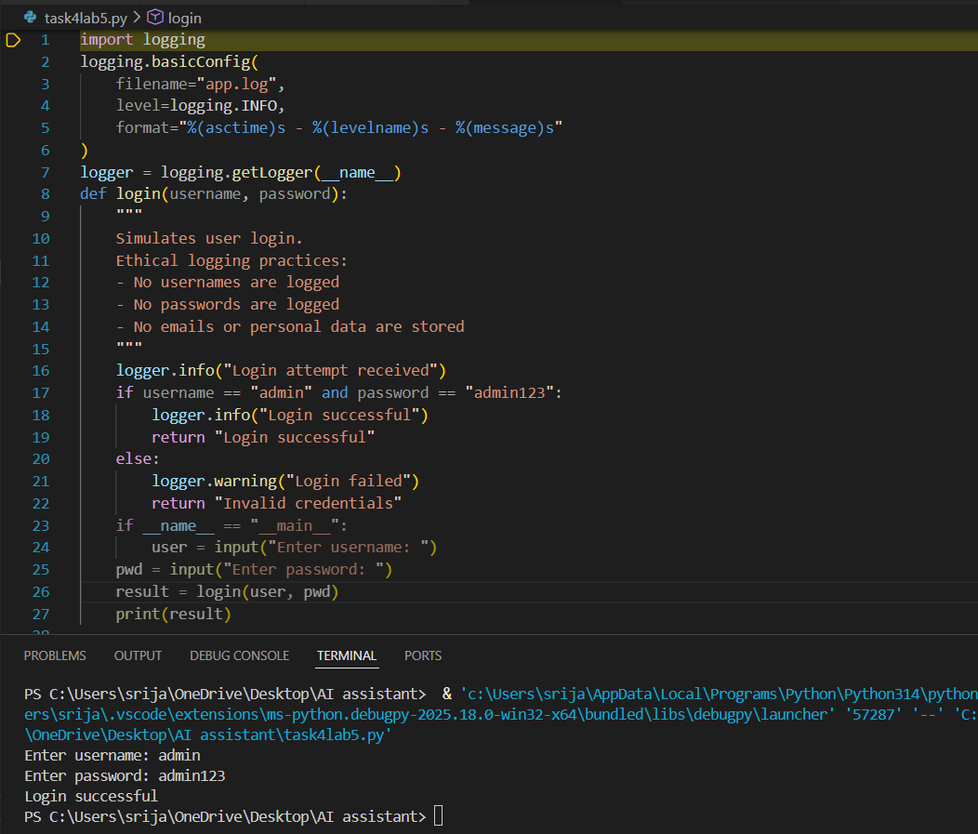
Task5
Prompt: Generate a Machine Learning Model
